CDC Information Sheet 5
CDC Claim Preparation
Processing Claims for CDC in TRACCS is very straight forward – because the normal day to day activity of rostering registers and substantiates the goods and services provided to CDC clients
Once services have been confirmed as part of the normal Rostering/Pay Approval process – agencies can process a CDC Claim by clicking on the CDC button on the main TRACCS menu.
This will display the CDC claim screen. Agencies simply nominate the start and end date for the claims they want to process for the next unprocessed claim period and click Start.
Claim finalisation is a 2 part process. Claim preparation calculates all due claims taking into account the level of each package, any supplements and all leave rules that apply for respite, hospital, transition and social leave.
The claims are processed and an audit list displayed to allow agencies to check and verify claims
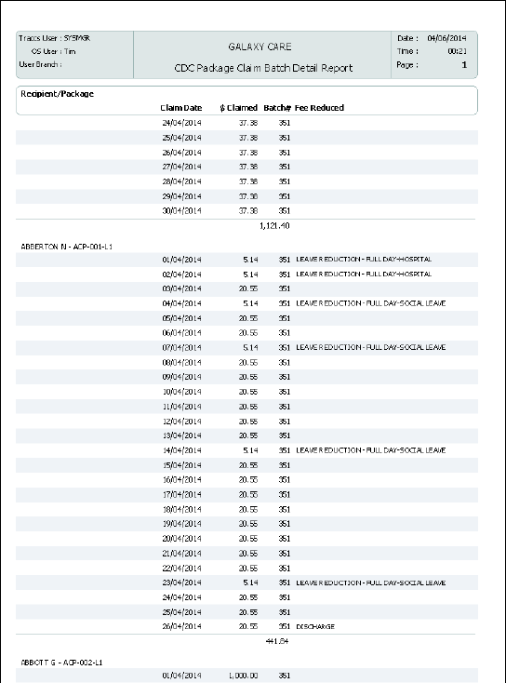
After verification agencies then run the Claim Update – which sets the balance for CDC Package statements for each client and accumulates all the usage charges against the statement
Statements can then be printed or emailed
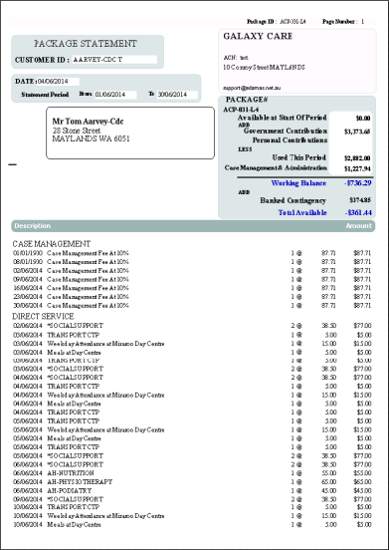
A sales journal export is available for agencies wishing to export usage information to an external finance package. It produces a csv file summarising all statements balances, usage and income/receipts for the nominated period in an easy to import csv format

