NDIA Information Sheet 2

NDIA Package Usage Dashboard

This allows users to do a fortnightly analysis of package usage from a nominated start date (with any pre-existing balance) and see both numerically and graphically the accumulated over/underspend on the package.

It also calculates a notional usage based on unexpired funds so agencies can advise clients what future fortnightly usage they would have available to stay within the limits of the current package after deducting total accumulated usage.

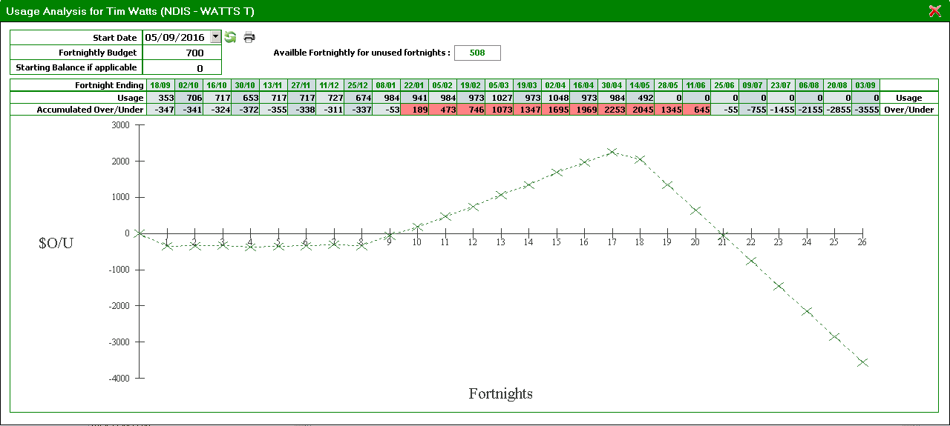

The dashboard is accessed by clicking on the dollar sign on the main client screen – which displays the funding and alerts summary. Then right clicking on the desired package – which displays a menu allowing display of Package Usage Analysis

